FREQUENCIES VARIABLES=TotalSpiritual RWB EWB TotalQoL QoLFisik QoLPsikologi QoLHubSosial
QoLLingkungan
/FORMAT=NOTABLE
/STATISTICS=STDDEV MINIMUM MAXIMUM MEAN MEDIAN
/HISTOGRAM NORMAL
/ORDER=ANALYSIS.

Frequencies

Notes
Output Created |  | 07-JAN-2023 15:41:56
Comments
Input | Active Dataset | DataSet0
Input | Filter | <none>
Input | Weight | <none>
Input | Split File | <none>
Input | N of Rows in Working Data File | 57
Missing Value Handling | Definition of Missing | User-defined missing values are treated as missing.
Missing Value Handling | Cases Used | Statistics are based on all cases with valid data.
Syntax |  | FREQUENCIES VARIABLES=TotalSpiritual RWB EWB TotalQoL QoLFisik QoLPsikologi QoLHubSosial  QoLLingkungan  /FORMAT=NOTABLE  /STATISTICS=STDDEV MINIMUM MAXIMUM MEAN MEDIAN  /HISTOGRAM NORMAL  /ORDER=ANALYSIS.
Resources | Processor Time | 00:00:02.58
Resources | Elapsed Time | 00:00:02.00

[DataSet0]

Statistics
 |  | TotalSpiritual | RWB | EWB | TotalQoL | QoLFisik | QoLPsikologi | QoLHubSosial | QoLLingkungan
N | Valid | 57 | 57 | 57 | 57 | 57 | 57 | 57 | 57
N | Missing | 0 | 0 | 0 | 0 | 0 | 0 | 0 | 0
Mean |  | 93.30 | 47.12 | 46.18 | 64.5789 | 57.75 | 65.33 | 67.58 | 67.65
Median |  | 91.00 | 47.00 | 46.00 | 64.0000 | 56.00 | 63.00 | 69.00 | 69.00
Std. Deviation |  | 11.274 | 6.555 | 5.682 | 8.85223 | 12.246 | 10.577 | 13.021 | 10.190
Minimum |  | 73 | 32 | 33 | 48.50 | 38 | 50 | 31 | 50
Maximum |  | 120 | 60 | 60 | 95.50 | 100 | 94 | 100 | 94

Histogram

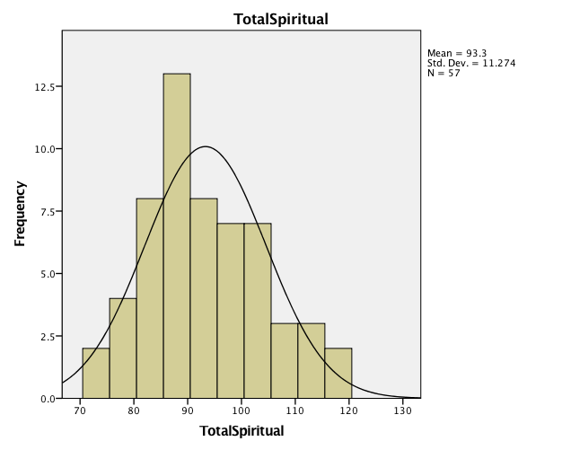

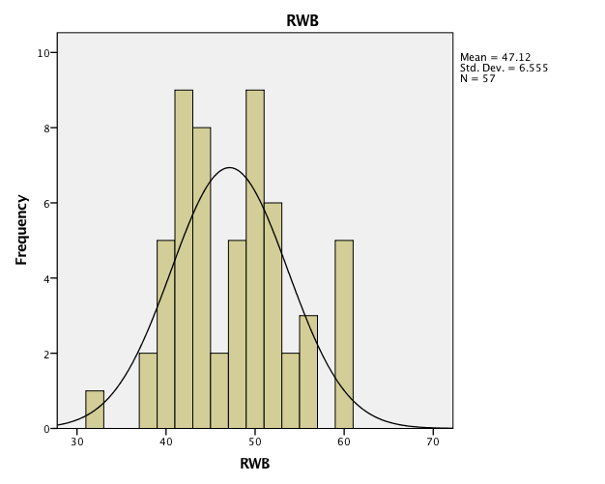

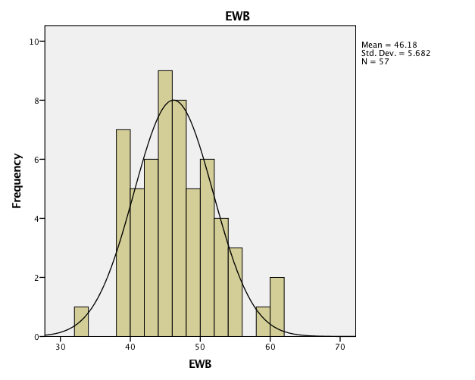

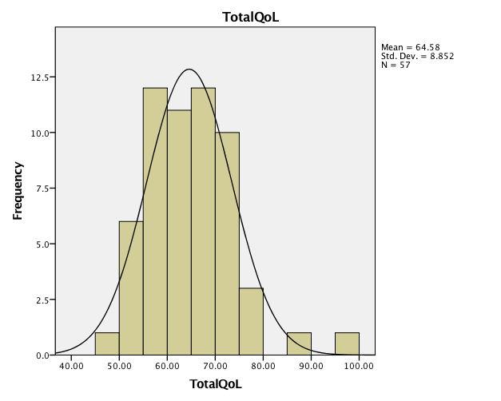

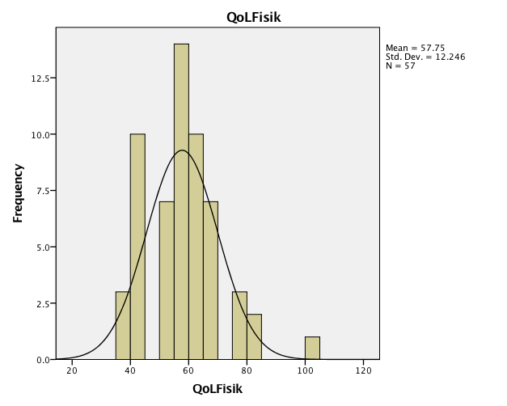

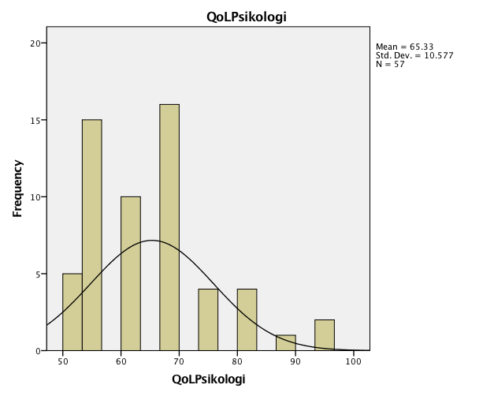

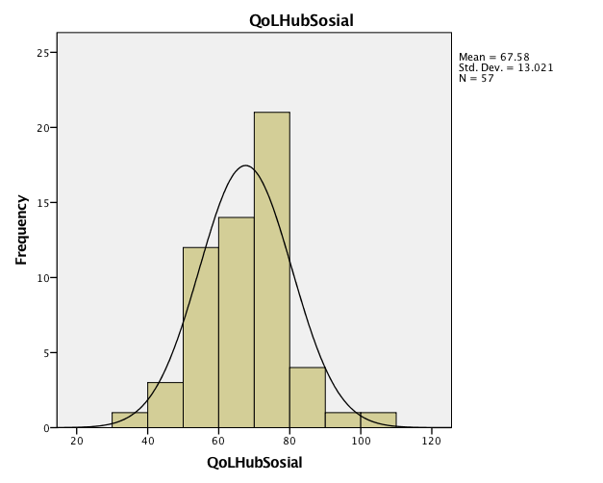

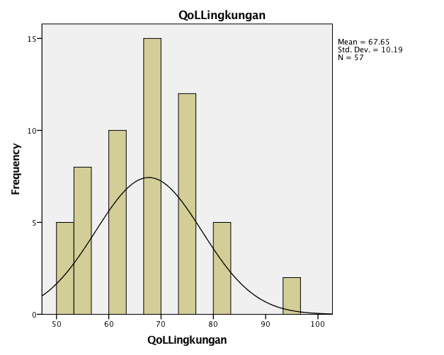

EXAMINE VARIABLES=TotalSpiritual RWB EWB TotalQoL QoLFisik QoLPsikologi QoLHubSosial QoLLingkungan
/PLOT NONE
/STATISTICS DESCRIPTIVES
/CINTERVAL 95
/MISSING LISTWISE
/NOTOTAL.

Explore

Notes
Output Created |  | 07-JAN-2023 15:43:13
Comments
Input | Active Dataset | DataSet0
Input | Filter | <none>
Input | Weight | <none>
Input | Split File | <none>
Input | N of Rows in Working Data File | 57
Missing Value Handling | Definition of Missing | User-defined missing values for dependent variables are treated as missing.
Missing Value Handling | Cases Used | Statistics are based on cases with no missing values for any dependent variable or factor used.
Syntax |  | EXAMINE VARIABLES=TotalSpiritual RWB EWB TotalQoL QoLFisik QoLPsikologi QoLHubSosial QoLLingkungan  /PLOT NONE  /STATISTICS DESCRIPTIVES  /CINTERVAL 95  /MISSING LISTWISE  /NOTOTAL.
Resources | Processor Time | 00:00:00.01
Resources | Elapsed Time | 00:00:00.00

Case Processing Summary
 | Cases
 | Valid |  | Missing |  | Total
 | N | Percent | N | Percent | N | Percent
TotalSpiritual | 57 | 100.0% | 0 | 0.0% | 57 | 100.0%
RWB | 57 | 100.0% | 0 | 0.0% | 57 | 100.0%
EWB | 57 | 100.0% | 0 | 0.0% | 57 | 100.0%
TotalQoL | 57 | 100.0% | 0 | 0.0% | 57 | 100.0%
QoLFisik | 57 | 100.0% | 0 | 0.0% | 57 | 100.0%
QoLPsikologi | 57 | 100.0% | 0 | 0.0% | 57 | 100.0%
QoLHubSosial | 57 | 100.0% | 0 | 0.0% | 57 | 100.0%
QoLLingkungan | 57 | 100.0% | 0 | 0.0% | 57 | 100.0%

Descriptives
 |  |  | Statistic | Std. Error
TotalSpiritual | Mean |  | 93.30 | 1.493
TotalSpiritual | 95% Confidence Interval for Mean | Lower Bound | 90.31
TotalSpiritual | 95% Confidence Interval for Mean | Upper Bound | 96.29
TotalSpiritual | 5% Trimmed Mean |  | 92.96
TotalSpiritual | Median |  | 91.00
TotalSpiritual | Variance |  | 127.106
TotalSpiritual | Std. Deviation |  | 11.274
TotalSpiritual | Minimum |  | 73
TotalSpiritual | Maximum |  | 120
TotalSpiritual | Range |  | 47
TotalSpiritual | Interquartile Range |  | 16
TotalSpiritual | Skewness |  | .428 | .316
TotalSpiritual | Kurtosis |  | -.388 | .623
RWB | Mean |  | 47.12 | .868
RWB | 95% Confidence Interval for Mean | Lower Bound | 45.38
RWB | 95% Confidence Interval for Mean | Upper Bound | 48.86
RWB | 5% Trimmed Mean |  | 47.05
RWB | Median |  | 47.00
RWB | Variance |  | 42.967
RWB | Std. Deviation |  | 6.555
RWB | Minimum |  | 32
RWB | Maximum |  | 60
RWB | Range |  | 28
RWB | Interquartile Range |  | 10
RWB | Skewness |  | .293 | .316
RWB | Kurtosis |  | -.393 | .623
EWB | Mean |  | 46.18 | .753
EWB | 95% Confidence Interval for Mean | Lower Bound | 44.67
EWB | 95% Confidence Interval for Mean | Upper Bound | 47.68
EWB | 5% Trimmed Mean |  | 45.96
EWB | Median |  | 46.00
EWB | Variance |  | 32.290
EWB | Std. Deviation |  | 5.682
EWB | Minimum |  | 33
EWB | Maximum |  | 60
EWB | Range |  | 27
EWB | Interquartile Range |  | 8
EWB | Skewness |  | .401 | .316
EWB | Kurtosis |  | .078 | .623
TotalQoL | Mean |  | 64.5789 | 1.17251
TotalQoL | 95% Confidence Interval for Mean | Lower Bound | 62.2301
TotalQoL | 95% Confidence Interval for Mean | Upper Bound | 66.9278
TotalQoL | 5% Trimmed Mean |  | 64.1754
TotalQoL | Median |  | 64.0000
TotalQoL | Variance |  | 78.362
TotalQoL | Std. Deviation |  | 8.85223
TotalQoL | Minimum |  | 48.50
TotalQoL | Maximum |  | 95.50
TotalQoL | Range |  | 47.00
TotalQoL | Interquartile Range |  | 12.63
TotalQoL | Skewness |  | .772 | .316
TotalQoL | Kurtosis |  | 1.631 | .623
QoLFisik | Mean |  | 57.75 | 1.622
QoLFisik | 95% Confidence Interval for Mean | Lower Bound | 54.50
QoLFisik | 95% Confidence Interval for Mean | Upper Bound | 61.00
QoLFisik | 5% Trimmed Mean |  | 57.19
QoLFisik | Median |  | 56.00
QoLFisik | Variance |  | 149.974
QoLFisik | Std. Deviation |  | 12.246
QoLFisik | Minimum |  | 38
QoLFisik | Maximum |  | 100
QoLFisik | Range |  | 62
QoLFisik | Interquartile Range |  | 13
QoLFisik | Skewness |  | .758 | .316
QoLFisik | Kurtosis |  | 1.243 | .623
QoLPsikologi | Mean |  | 65.33 | 1.401
QoLPsikologi | 95% Confidence Interval for Mean | Lower Bound | 62.53
QoLPsikologi | 95% Confidence Interval for Mean | Upper Bound | 68.14
QoLPsikologi | 5% Trimmed Mean |  | 64.69
QoLPsikologi | Median |  | 63.00
QoLPsikologi | Variance |  | 111.869
QoLPsikologi | Std. Deviation |  | 10.577
QoLPsikologi | Minimum |  | 50
QoLPsikologi | Maximum |  | 94
QoLPsikologi | Range |  | 44
QoLPsikologi | Interquartile Range |  | 13
QoLPsikologi | Skewness |  | .754 | .316
QoLPsikologi | Kurtosis |  | .460 | .623
QoLHubSosial | Mean |  | 67.58 | 1.725
QoLHubSosial | 95% Confidence Interval for Mean | Lower Bound | 64.12
QoLHubSosial | 95% Confidence Interval for Mean | Upper Bound | 71.03
QoLHubSosial | 5% Trimmed Mean |  | 67.77
QoLHubSosial | Median |  | 69.00
QoLHubSosial | Variance |  | 169.534
QoLHubSosial | Std. Deviation |  | 13.021
QoLHubSosial | Minimum |  | 31
QoLHubSosial | Maximum |  | 100
QoLHubSosial | Range |  | 69
QoLHubSosial | Interquartile Range |  | 19
QoLHubSosial | Skewness |  | -.530 | .316
QoLHubSosial | Kurtosis |  | .471 | .623
QoLLingkungan | Mean |  | 67.65 | 1.350
QoLLingkungan | 95% Confidence Interval for Mean | Lower Bound | 64.95
QoLLingkungan | 95% Confidence Interval for Mean | Upper Bound | 70.35
QoLLingkungan | 5% Trimmed Mean |  | 67.38
QoLLingkungan | Median |  | 69.00
QoLLingkungan | Variance |  | 103.839
QoLLingkungan | Std. Deviation |  | 10.190
QoLLingkungan | Minimum |  | 50
QoLLingkungan | Maximum |  | 94
QoLLingkungan | Range |  | 44
QoLLingkungan | Interquartile Range |  | 12
QoLLingkungan | Skewness |  | .213 | .316
QoLLingkungan | Kurtosis |  | .142 | .623

CORRELATIONS
/VARIABLES=TotalSpiritual TotalQoL
/PRINT=TWOTAIL NOSIG
/MISSING=PAIRWISE.

Correlations

Notes
Output Created |  | 07-JAN-2023 15:44:17
Comments
Input | Active Dataset | DataSet0
Input | Filter | <none>
Input | Weight | <none>
Input | Split File | <none>
Input | N of Rows in Working Data File | 57
Missing Value Handling | Definition of Missing | User-defined missing values are treated as missing.
Missing Value Handling | Cases Used | Statistics for each pair of variables are based on all the cases with valid data for that pair.
Syntax |  | CORRELATIONS  /VARIABLES=TotalSpiritual TotalQoL  /PRINT=TWOTAIL NOSIG  /MISSING=PAIRWISE.
Resources | Processor Time | 00:00:00.01
Resources | Elapsed Time | 00:00:00.00

Correlations
 |  | TotalSpiritual | TotalQoL
TotalSpiritual | Pearson Correlation | 1 | .383**
TotalSpiritual | Sig. (2-tailed) |  | .003
TotalSpiritual | N | 57 | 57
TotalQoL | Pearson Correlation | .383** | 1
TotalQoL | Sig. (2-tailed) | .003
TotalQoL | N | 57 | 57
**. Correlation is significant at the 0.01 level (2-tailed).

